Support Ticketing System Implementation

The project's goal is to create and deploy a support ticketing system for an IT consulting business, which will enhance the tracking and handling of customer requests and issues. The system will provide a centralised repository and an organised workflow for managing tickets, replacing the current method of handling issues via phone calls and emails.
Aim and objective:
- Develop a centralised system for tracking client issues and requests.
- Implement Service Level Agreements (SLAs) to ensure timely resolution of tickets.
- Improve efficiency and transparency in issue resolution.
- Enhance client satisfaction through a structured and monitored support process.

Scope
In Scope:
- Development and configuration of a Support Ticketing System.
- Integration with existing communication channels (email, phone).
- Implementation of SLAs within the system.
- Training for users on the new system.
- Continuous monitoring and improvement plan.

Out of Scope:
- Custom development of additional features beyond the standard ticketing system.
- Integration with non-IT related business processes.
- Ongoing support and maintenance post-implementation.

Stakeholders
- Project Sponsor: John Doe, CEO
- Project Manager: Jane Smith, Project Manager
- IT Team: Developers, System Administrators
- Support Team: Level 1, Level 2, and Level 3 Support Staff
- Clients: Internal and External Users

IT Team:
Business Analyst:
Gather and Document Requirements from Stakeholders:
- Conduct interviews, surveys, and workshops with stakeholders to understand their needs and requirements.
- Create detailed documentation, including use cases, user stories, and functional specifications.
Translate Business Needs into Technical Specifications:
- Develop technical requirements and specifications based on business needs and objectives.
- Create diagrams and models to illustrate the system’s functionality and processes.
Ensure Alignment Between Business Goals and the System’s Functionality:
- Continuously review and refine requirements to ensure they meet the business goals.
- Act as a liaison between the business stakeholders and the development team to ensure clear communication and understanding.
Developer:
Configure and Customise the Ticketing System:
- Set up and configure the ticketing system according to the project requirements.
- Customise the system to fit the specific needs of the organisation, including workflows, forms, and user interfaces.
Write Code and Develop Necessary Features:
- Develop custom features and functionality as needed.
- Implement integrations with other systems and tools used by the organisation.
Ensure Software Quality Through Unit Testing:
- Write and execute unit tests to ensure code quality and functionality.
- Participate in code reviews to maintain high coding standards and best practices.

Tester:
Develop and Execute Test Plans:
- Create comprehensive test plans that cover all aspects of the system, including functional, regression, and performance testing.
- Execute test cases and document the results.
Identify, Document, and Track Bugs:
- Identify defects and issues in the system, document them clearly, and track their resolution.
- Work closely with developers to ensure that bugs are fixed and retested.
Verify Fixes and Ensure the System Meets Quality Standards:
- Perform re-testing and regression testing to verify that bugs have been fixed and that no new issues have been introduced.
- Ensure the system meets the quality standards set by the project and stakeholders.
Architect:
Design the Overall System Architecture:
- Develop the overall system architecture, ensuring it meets the project’s requirements and constraints.
- Create architectural diagrams and documentation to guide the development team.
Ensure the System is Scalable, Secure, and Meets Performance Requirements:
- Design the system to be scalable, ensuring it can handle increased load and usage over time.
- Implement security best practices to protect the system and its data.
- Optimise the system’s performance to meet the required benchmarks and standards.
Oversee Technical Standards and Integration with Existing Systems:
- Establish and enforce technical standards and best practices for the project.
- Ensure the system integrates seamlessly with existing systems and infrastructure.
- Provide technical guidance and support to the development team throughout the project.

Roles and Responsibilities:
- Project Sponsor: Approve the project and provide necessary resources.
- Project Manager: Oversee the project, manage timelines, and ensure milestones are met.
IT Team:
- Developers: Configure and customise the ticketing system.
- System Administrators: Ensure the system is properly integrated and secure.
Support Team:
- Level 1 Support: Acknowledge and resolve tickets at the first point of contact.
- Level 2 Support: Provide in-depth analysis and resolve escalated tickets.
- Level 3 Support: Handle complex technical issues and provide expert solutions.
- Clients: Use the system to raise tickets and provide feedback.

Milestones
1. Project Planning and Initiation: June 10, 2024
2. Requirements Gathering: June 15, 2024
3. System Design and Architecture: June 30, 2024
4. Development and Configuration: July 31, 2024
5. Integration and Testing: August 15, 2024
6. User Training and Documentation: August 25, 2024
7. Pilot Testing: September 10, 2024
8. Full Deployment: September 30, 2024

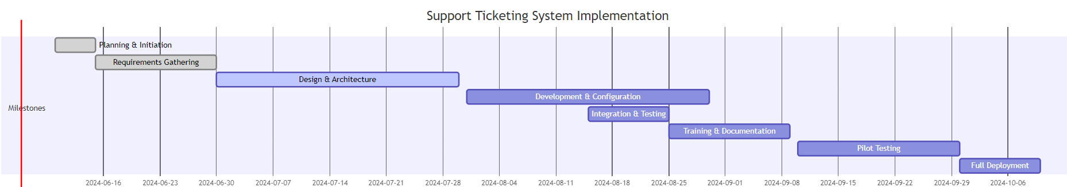
Gantt Chart:

Budget
  - Software Licenses: £10,000
  - Development Costs: £25,000
  - Training and Documentation: £5,000
  - Miscellaneous Expenses: £3,000
  - Total Estimated Budget: £43,000

Risks, Constraints, Assumptions
Risks:
  - Delays in software acquisition or configuration.
  - Resistance to change from users accustomed to the current system.
  - Technical issues during integration with existing systems.
Constraints:
  - Budget limitations could affect scope.
  - Strict deadlines for each milestone.
Assumptions:
  - Adequate resources and support will be available.
  - Stakeholders will provide timely feedback and approval.
  - Existing infrastructure will support the new system.

Project Approval
This section will include signature spaces for the project sponsor, client, and project manager.

Project Sponsor:
Signature: ______________________
Date: __________________________

Client:

Signature: ______________________
Date: ______________________
Project Manager:
Signature: ______________________
Date: __________________________

